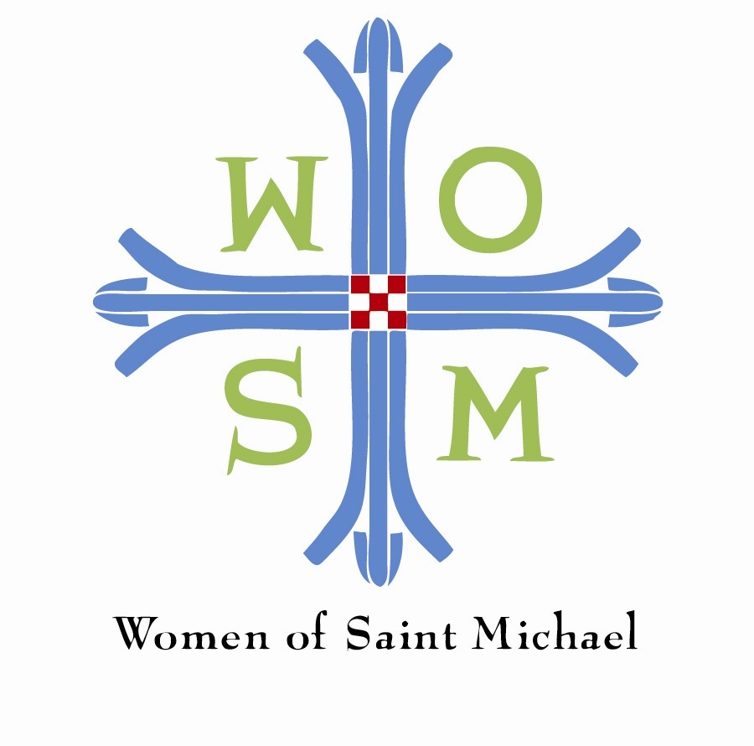

WOMEN OF SAINT MICHAEL 2018 GRANT - FINAL REPORT

SECTION 1: NARRATIVE REPORT

Grant Period: May 2018 – April 2019

Report Date: ____________________

Organization: ___________________________________

1. Please briefly describe the purpose of the grant.
2. What program outcomes did you achieve with this grant? Please be as specific as possible.
3. Did you achieve any special, positive outcomes from your grant that were unforeseen?
4. Please share any significant “lessons learned.”
5. Please share a success story.

SECTION 2: FINANCIAL REPORT

Total Grant Award: $__________

Grant Expenditures Chart: May 2018 thru April 2019

Grant Budget Line Items* | $ amount Approved | $ amount expended | Variance Explanation  (if applicable)
Totals | $ | $ | $

*Note: Please add additional lines to chart, if needed.

SECTION 3: SIGNATURES

Final Report reviewed and approved by (both signatures required):

Chief Executive Officer/Executive Director (Type Name): ______________________________

(Signature) ___________________________________________

(Date of Signature) _____________________________________

President or Chairman of the Board: (Type Name): ___________________________________

(Signature) ___________________________________________

(Date of Signature) _____________________________________

Please complete this form when funds are expended. You may include report with your 2018 application or mail Return Final Report and Signature Page to:

The Women of Saint Michael Gifts Committee
Saint Michael and All Angels Episcopal Church
8011 Douglas, Dallas, TX 75225

Please note: Submission of this Final Report Form is required for future WOSM funding.

Thank you!

